**Reflective Writing**

*A great deal of your time at university will be spent thinking; thinking about what people have said, what you have read, what you yourself are thinking and how your thinking has changed. It is generally believed that the thinking process involves two aspects: reflective thinking and critical thinking. They are not separate processes; rather, they are closely connected (Brookfield 1987).*

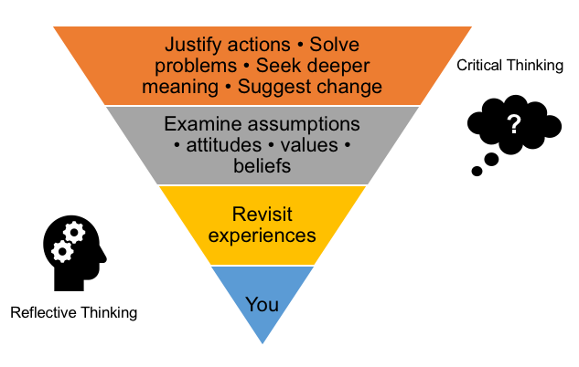

**Figure 1:** The Thinking Process (adapted from Mezirow 1990, Schon 1987, Brookfield 1987)

**Reflective thinking**

**Reflection is:**

* a form of personal response to experiences, situations, events or new information.
* a 'processing' phase where thinking and learning take place.

There is neither a right nor a wrong way of reflective thinking, there are just questions to explore.

**Figure 1** shows that the reflective thinking process starts with you. Before you can begin to assess the words and ideas of others, you need to pause and identify and examine your own thoughts.

Doing this involves revisiting your prior experience and knowledge of the topic you are exploring. It also involves considering how and why you think the way you do. The examination of your beliefs, values, attitudes and assumptions forms the foundation of your understanding.

Reflective thinking demands that you recognise that you bring valuable knowledge to every experience. It helps you therefore to recognise and clarify the important connections between what you already know and what you are learning. It is a way of helping you to become an active, aware and critical learner.

**Reflective writing is:**

* documenting your response to experiences, opinions, events or new information
* communicating your response to thoughts and feelings
* a way of exploring your learning
* an opportunity to gain self-knowledge
* a way to achieve clarity and better understanding of what you are learning
* a chance to develop and reinforce writing skills
* a way of making meaning out of what you study

**Reflective writing is not:**

* just conveying information, instruction or argument
* pure description, though there may be descriptive elements
* straightforward decision or judgement, e.g. about whether something is right or wrong, good or bad
* simple problem-solving
* a summary of course notes
* a standard university essay.

**How Do I Write Reflectively?**

**Writing Style**

Because it concerns your thoughts, reflective writing is mostly **subjective**. Therefore, in addition to being **reflective** and **logical**, you can be **personal, hypothetical, critical** and **creative**. You can comment about your experiences, rather than solely drawing on academic evidence.

Reflective writing is an activity that includes **description** (what, when, who) and **analysis** (how, why, what if). It is an explorative tool often resulting in more questions than answers.

A reflective task may allow you to use different modes of writing and language:

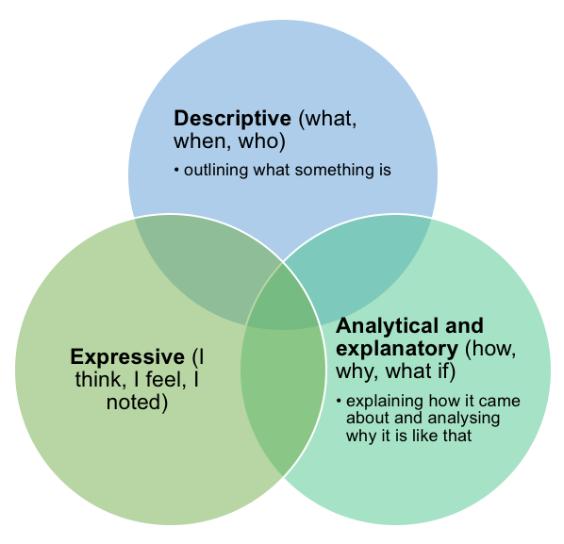

Use full sentences and complete paragraphs for your reflections. Reflective writing is often less formal—you can usually use personal pronouns like 'I', 'my' or 'we' - but keep colloquial language to a minimum, e.g. terms like kid, bloke, stuff.

**What can I discuss?**

* Your **perceptions** of the course and the content.
* Any **questions** you have.
* **Experiences, ideas and observations** you have had, and how they relate to the course or topic.
* What you found confusing, inspiring, difficult, interesting and **why**.
* **Possibilities, speculations, hypotheses or solutions.**
* **Alternative interpretations** or different perspectives on what you have read or done in your course.
* How new ideas **challenge** what you already know.
* **What you need to explore next** in terms of thoughts and actions.

 You can also discuss **how** you:

* solved a **problem**
* reached a **conclusion**
* found an **answer**
* reached a point of **understanding.**

It's also helpful to make **comparisons** and **connections** between what you are learning and your prior knowledge and experience and your prior assumptions.

[**Getting started**](javascript:void(0))

**Be clear about your task**

Reflective writing assignments can take many forms, so **check the guidelines in your course outline** before you begin. Clarify any questions or uncertainties with your lecturer or tutor.

**Clarify the practical aspects**

Find out what form your task should take. You may need to submit a book or folder or complete an online component. In addition to writing, you may be able to include pictures, diagrams, media clippings etc.

**Gather your ideas**

Before you write, you need to think and reflect. Start by drawing a **mind map.**

**Mind mapping** is a technique that can help you expand your thinking, structure your ideas, and make connections. You can use a **mind map** to plan your assignment and arrange items to create the structure of your writing.

1. Write your topic in the centre of a blank page.
2. Draw related ideas on 'branches' that radiate from the central topic. When you get a new idea, start a new branch from the centre. Include any ideas, topics, authors, theories, experiences associated with your topic.
3. Map quickly, without pausing, to maintain a flow of ideas. Associate freely and do not self-edit; at this stage anything and everything is OK.
4. Circle the key points or ideas. Look at each item and consider how it relates to others, and to the topic as a whole.
5. Map the relationships between the ideas or key points using lines, arrows, colours. Use words or phrases to link them.

**Resources on Mind Mapping**

* [**Mind Map Gallery**](https://mindwerx.com/buzan-mind-mapping/) - The Buzan Centre Australia / NZ
* [**Brainstorming and mind mapping for assignments**](https://www.monash.edu/rlo/research-writing-assignments/understanding-the-assignment/brainstorming) - Language and Learning Online, Monash University
* [**Concept or mind-mapping**](http://www.studygs.net/mapping/) - Study Guides and Strategies web site

[**Tips to help you in your reflective writing process**](javascript:void(0))

* Think of an interaction, event or episode you experienced that can be connected to the topic.
* Describe what happened.
* What was your role?
* What feelings and perceptions surrounded the experience?
* How would you explain the situation to someone else?
* What might this experience mean in the context of your course?
* What other perspectives, theories or concepts could be applied to the situation?
* **Examples of Reflective Writing**
* **Types of reflective writing assignments**
* **A journal** requires you to write weekly entries throughout a semester. May require you to base your reflection on course content.
* **A learning diary** is similar to a journal, but may require group participation. The diary then becomes a place for you to communicate in writing with other group members.
* **A logbook** is often used in disciplines based on experimental work, such as science. You note down or 'log' what you have done. A log gives you an accurate record of a process and helps you reflect on past actions and make better decisions for future actions.
* **A reflective note** is often used in law. A reflective note encourages you to think about your personal reaction to a legal issue raised in a course.
* **An essay diary** can take the form of an annotated bibliography (where you examine sources of evidence you might include in your essay) and a critique (where you reflect on your own writing and research processes).
* **a peer review** usually involves students showing their work to their peers for feedback.
* **A self-assessment task** requires you to comment on your own work.
* **Some examples of reflective writing**
* **Social Science fieldwork report (methods section)**

|  |  |
| --- | --- |
| The field notes were written by hand on lined paper. They consisted of jotted notes and mental triggers (personal notes that would remind me of specific things when it came to writing the notes up). I took some direct observational notes recording what I saw where this was relevant to the research questions and, as I was aiming to get a sense of the culture and working environment, I also made researcher inference notes **[1]** **[2]**.  **[3]** I found the note-taking process itself helpful, as it ensured that I listened carefully and decoded information. Not all the information I recorded was relevant but noting what I found informative contributed to my ability to form an overview on re-reading. However, the reliability of jotted notes alone can be questionable. For example, the notes were not a direct transcription of what the subjects said but consisted of pertinent or interesting information.  Rarely did I have time to transcribe a direct quotation, so relied on my own fairly rapid paraphrasing, which risks changing the meaning. Some technical information was difficult to note down accurately **[3]**. A tape recorder would have been a better, more accurate method. However, one student brought a tape recorder and was asked to switch it off by a participant who was uneasy about her comments being directly recorded. It seems that subjects feel differently about being recorded or photographed (as opposed to observers taking notes), so specific consent should be sought before using these technologies **[4]**. | **1.** Description/ explanation of method.    **2.** Includes discipline-specific language    **3.** Critical evaluation of method    **4.** Conclusion and recommendation based on the writer's experience |

* **Engineering Design Report**

|  |  |
| --- | --- |
| Question: Discuss at least two things you learnt or discovered – for example about design or working in groups or the physical world – through participating in the Impromptu Design activities.  Firstly, the most obvious thing that I discovered was the advantage of working as part of a group **[1]**. I learned that good teamwork is the key to success in design activities when time and resources are limited. As everyone had their own point of view, many different ideas could be produced, and I found the energy of group participation made me feel more energetic about contributing something **[2]**.  Secondly I discovered that even the simplest things on earth could be turned into something amazing if we put enough creativity and effort into working on them **[1]**. With the Impromptu Design activities **[3]** we used some simple materials such as straws, string, and balloons, but were still able to create some 'cool stuff' **[4]**. I learned that every design has its weaknesses and strengths and working with a group can help discover what they are. We challenged each other's preconceptions about what would and would not work. We could also see the reality of the way changing a design actually affected its performance. | **1.** Addresses the assignment question  **2.** Reflects on direct experiences  **3.** Direct reference to the course activity  **4.** The style is relatively informal, yet still uses full sentences.  **5.** Relating what was learnt. |

* **Learning Journal (weekly reflection)**

|  |  |
| --- | --- |
| Last week's lecture presented the idea that science is the most powerful form of evidence **[1]**. My position as a student studying both physics and law makes this an important issue for me **[2]** and one I was thinking about while watching the 'The New Inventors' television program last Tuesday **[3]**. The two 'inventors' (an odd name considering that, as Smith (2002) says, nobody thinks of things in a vacuum) were accompanied by their marketing people. The conversations were quite contrived, but also funny and enlightening. I realised that the marketing people used a certain form of evidence to persuade the viewers (us?) of the value of the inventions **[4]**. To them, this value was determined solely by whether something could be bought or sold—in other words, whether something was 'marketable'. In contrast, the inventors seemed quite shy and reluctant to use anything more than technical language, almost as if this was the only evidence required – as if no further explanation was needed.    This difference forced me to reflect on the aims of this course—how communication skills are not generic but differ according to time and place. Like in the 'Research Methodology' textbook discussed in the first lecture, these communication skills are the result of a form of triangulation, **[5]** which I have made into the following diagram:  ... | **1.** Description of topic encountered in the course  **2.** The author's voice is clear  **3.** Introduces 'everyday' life experience  **4.** The style is relatively informal, yet still uses full sentences  **5.** Makes an explicit link between 'everyday' life and the topic |

* **References**
* Brookfield, S 1987, *Developing critical thinkers: challenging adults to explore alternative ways of thinking and acting*, Open University Press, Milton Keynes.
* Mezirow, J 1990, *Fostering critical reflection in adulthood: a guide to transformative and emancipatory learning*, Jossey-Bass, San Francisco.
* Schön, DA 1987, *Educating the reflective practitioner*, Jossey-Bass. San Francisco.
* The Learning & Career Hub thanks the students who permitted us to feature examples of their writing.
* Prepared by The Learning & Career Hub, The University of New South Wales © 2019. This guide may be distributed or adapted for educational purposes. Full and proper acknowledgement is required. Contact us here: [**sacs@unsw.edu.au**](mailto:sacs@unsw.edu.au)

https://student.unsw.edu.au/reflective-writing